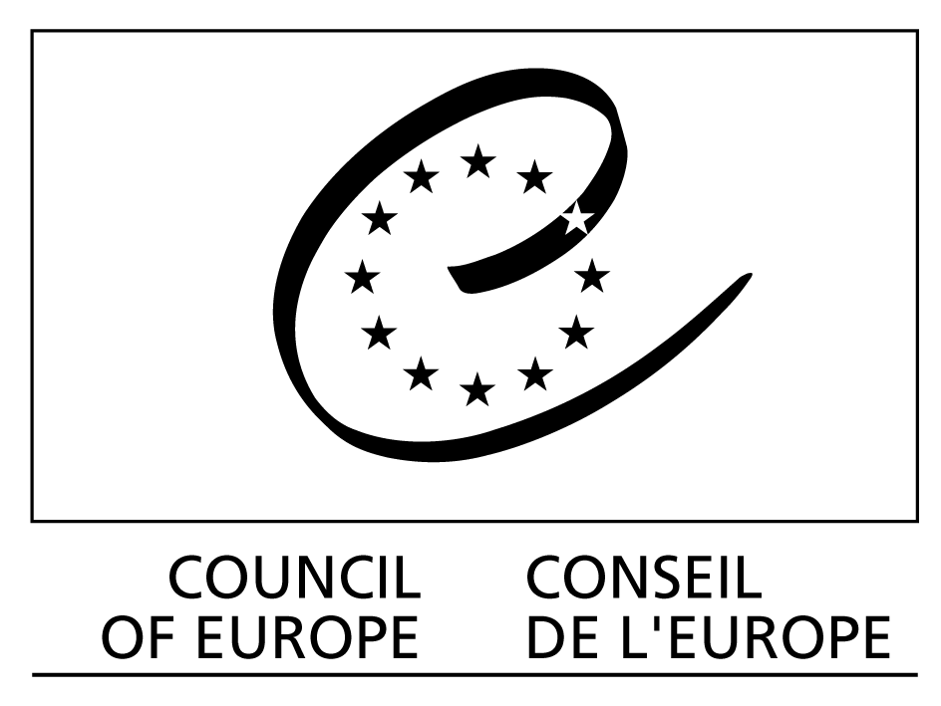

CCPE(2010)1

Strasbourg, 20 October 2010

CONSULTATIVE COUNCIL OF EUROPEAN PROSECUTORS
(CCPE)

Opinion No. 5

Public prosecution and juvenile justice

YEREVAN DECLARATION

This Declaration was adopted during the 5th plenary meeting of the CCPE, which took place in Yerevan (Armenia) on 19-21 October 2010.
YEREVAN DECLARATION

Introduction

- The Consultative Council of European Prosecutors (CCPE) was established by the Committee of Ministers of the Council of Europe in 2005 with the task of rendering Opinions regarding the functioning of prosecution services and promoting the effective implementation of Recommendation Rec(2000)19 of the Committee of Ministers to member States on the role of public prosecution in the criminal justice system.

- For 2010, the Committee of Ministers instructed the CCPE, in the light of Resolution No. 2 on child-friendly justice, to adopt an Opinion on "the principles of public policy in juvenile justice" and to examine, inter alia, the place juveniles have prior to, during and after the judicial proceedings, the way in which the interests of juveniles can be taken into account during such proceedings and the improvements concerning the methods used by authorities to provide information to juveniles on their rights and access to justice, including the access to the European Court of Human Rights.

- Public Prosecutors are public authorities who, on behalf of society and in the public interest, ensure the application of the law where a breach of the law carries a criminal sanction. In doing so, prosecutors take into account both the rights of individuals and the necessary effectiveness of the criminal justice system, in accordance with Recommendation Rec(2000).

- The role of prosecutors varies considerably from one State to another and the aim of this Opinion is to establish guidelines that should guide the action of all prosecutors involved in juvenile justice. This Opinion is to ensure that in all proceedings regarding juveniles, in which public prosecutors are involved, certain fundamental principles are applied with due regard to the level of maturity, vulnerability and mental capacity of the juvenile, whether as a juvenile who infringes the law, a victim or a witness. Compliance with these principles applies at all stages of the procedure, which means before the trial, during the hearing, during the enforcement of the decision and during the execution of decisions concerning juveniles.

- In cases involving juveniles, prosecutors should pay special attention to striking the appropriate balance between, on the one hand the interest of society and the goals of justice, and on the other hand the interests, special needs and vulnerability of juveniles.

- In States where prosecutors have competences outside the criminal law field (for example in family, custodian and administrative laws), they should always promote fundamental rights and freedoms, and in particular principles concerning special protection of juveniles as stated in this Opinion.

- The following principles apply where these are within the competences of the prosecutors and in accordance with their national law.

- Principles referred to in this Opinion concerning minors may also be applied to young adults.

- Moreover, the CCPE expresses the wish that member States should take proper measures combating the other socio-economic roots that may lead to juvenile offences (for example, homelessness, unemployment, lack of education).

Reference documents

- The CCPE has written this Opinion based on replies from 37 member States to a specific questionnaire on this subject.

- This Opinion is based on universal and regional legal instruments, including the case-law of the Court in this matter.

- The CCPE also took into account the work and conclusions of the 7th Conference of Prosecutors General of Europe (Moscow, 2006) on “the role of public prosecution in the protection of individuals", as well as the CCPE

Opinions No. 2 on alternatives to prosecution, No. 3 on the role of prosecution services outside the criminal law field and No. 4 on the relations between judges and prosecutors in a democratic society.

Definitions

- For the purpose of this Opinion, the CCPE refers to the definitions contained in paragraph 21 of Recommendation Rec(2008)11 on the European Rules for juvenile offenders subject to sanctions or measures and point I of Recommendation Rec(2003)20 concerning new ways of dealing with juvenile delinquency and the role of juvenile justice :

(i) “Juvenile/minor” means a person below the age of 18 years;

(ii) "Juvenile offender" means a person below the age of 18, who is alleged to have or who has committed an offence;

(iii) “Offence" means any act or omission that infringes the law and implies a sanction and is dealt with by a criminal court or any other judicial or administrative authority.

Peculiarities of the juvenile justice

- Juvenile justice should receive special attention from all judicial, law enforcement and social actors because of the fragility of those who are submitted to it. In all justice systems, the prosecutor should take into account the juvenile’s state of minority, the possible mitigating effect on his/her level of responsibility due to that minority and pay particular attention to his/her rights.

- The following measures should, where appropriate, be considered:
- video or audio taping of testimonies given by juveniles, interviewing of juveniles carried out with the assistance of child psychologists, pedagogues, social workers or other experts;
- interviewing of juveniles carried out, where appropriate, in the presence of the holder of parental responsibility or another person close to the juvenile or social services;
- interrogation rooms especially adapted for children. The number of interviews of young juvenile victims should be as limited as possible;
- interviews must be carried out in ways in which repeated victimization is avoided.

- Prosecutors should strive to promote measures aimed at preventing offending by juveniles who, because of their fragility, are likely to commit offences. Parents should be consulted and involved in the implementation of these measures.

- Sanctions should take into account the education, training, personal environment and personality of the concerned juveniles and not just punish criminal offences or other wrongful behaviours. Measures which restrict the freedom of juveniles should be specified by law and limited to the strict requirements needed to protect society.

- According to his/her competences, the prosecutor should seek to ensure that any contact by a juvenile, whether as an offender, a victim or a witness, with the justice system should be subject to special attention, in order to allow him/her to receive the necessary information, by means understandable for his/her age, concerning the conduct of the proceedings, the role of judicial actors and the measures taken for him/her.

- Prosecutors should have the necessary and appropriate means to exercise their competences with juveniles or these means should be attributed to other competent services in charge of juveniles. In particular, a system of recruitment, appropriate training as well as necessary staff, means and specialised services should be provided to them. Moreover, member States should consider setting up specialised units or officers for juvenile delinquency.

- In criminal investigations or prosecution and other proceedings involving juveniles, prosecutors should pay special attention to the timeframe and should seek to make sure that such cases are treated as a priority and carried out without any unjustified delay. A lengthy procedure may aggravate the negative impact of the committed offence and may hinder the proper re-habilitation of both a juvenile offender and a juvenile victim.

- Prosecutors should be aware that according to international standards, children deprived of their liberty must, as a main rule, be separated from adults and shall have the right to maintain contact with their family.

- The interest of society requires that the media be provided with the necessary information concerning the functioning of the justice system. However, exposure to the media may be particularly harmful to juveniles involved in criminal investigations and other procedures. Prosecutors should therefore be especially aware of their responsibility not to reveal any information that might violate the rights of the juveniles involved or, information that might lead to increase their prejudice.

- The exchange of experiences among prosecutors and international co-operation on the topic of juvenile justice is highly recommended.

Juveniles before the trial

- In order to have a better knowledge of the situation of the juvenile involved in a procedure, prosecutors should, within their competences, play a key role in the co-ordination and co-operation of the main actors in the criminal investigation stage, e.g. police, probation and social services.

- Prosecutors should, where appropriate, seek the advice of social services, specialised child protection services prior to making the decision on whether or not to prosecute the juveniles involved. Prosecutors should also seek their advice prior to taking a decision on which sanction or measure to propose to the Court. They should also be aware of and use, if appropriate, special technical hearing facilities for minors and experts (see paragraph 16 above).

- Having in mind the possible damaging impact of criminal and other proceedings on the future development of juveniles, prosecutors should, to the widest possible extent and according to the law, seek alternatives to prosecution of juvenile offenders, where such alternatives constitute a proper judicial response to the offence, taking into consideration the interest of the victims and of the general public and being consistent with the goals of juvenile justice.

- According to international standards, pre-trial detention of juveniles should only be used as a measure of last resort and for the shortest possible time. When dealing with juveniles, prosecutors should be especially cautious in considering whether the grounds of pre-trial detention can be achieved through less intrusive measures and ensure that pre-trial detention of juveniles takes place under conditions that can help minimise the possible negative consequences of the detention.

- Guidelines or recommendations on appropriate measures for different types of juvenile offences could be useful to ensure equality before the law.

Juveniles in the trial

- The aim to ensure the well-being and the interests of juveniles during trial should be shared by all prosecutors. Prosecutors should seek to minimize any excessive harm to offenders, victims and witnesses by the criminal procedure, where appropriate, when a protective approach can help.

- The prosecutor should seek to ensure that the juvenile is made aware of the charges against him/her, and able to fully exercise his/her proper defence, in order for the juvenile to present explanations and benefit from a legal assistance in all proceedings where he/she is involved, and to be able to speak freely before the competent court.

Execution of decisions concerning juveniles

- As regards juvenile justice, prosecutors should, where this is within their competences, seek to ensure that educational and socialisation measures, such as reparation, education, supervision by social services, treatment, placement in special juvenile facilities, mediation, as well as judicial supervision, probation and conditional release, are used to the widest possible extent, while at the same time taking into account the interest of the victim, the public interest, the interest of the juvenile as well as the goals of criminal justice.

- Where this is within their competences, prosecutors should supervise the legality of the implementation of all sanctions and measures, as well as education in specialised facilities for juveniles and carry out regular inspections in all penitentiary specialised institutions for juveniles. These inspections should also concern facilities for the pre-trial detention of juvenile suspects.

- Prosecutors should, where this is within their competences, ensure that juveniles, who have committed offences and who are subject to a judicial measure or sanction, are monitored and assisted in order to avoid the risk of reoffending.

- Member States are invited to regularly verify the implementation in their national system of the Recommendation Rec(2000)19, in particular as regards juvenile justice as described in this Opinion.

See terms of reference of the CCPE for 2009-2010 (1044th meeting of the Ministers’ Deputies, 10 December 2008).
Resolution adopted by the 28th Conference of the European Ministers of Justice (Lanzarote, Spain, October 2007).
See document CCPE-GT(2010)1REV6.
See in particular the United Nations legal instruments, including: the United Nations Convention on the Rights of the Child (20 November 1989); United Nations Minimum Rules for the Administration of Juvenile Justice (“The Beijing Rules”, 29 November 1985); United Nations Guidelines for the Prevention of Juvenile Delinquency (“The Riyadh Guidelines”, 14 December 1990); United Nations Rules for the Protection of Juveniles Deprived of their Liberty (“The Havana Rules”, 14 December 1990). See also United Nations General Comment No. 10 of the Committee on the Rights of the Child on Children’s rights in Juvenile Justice (CRC/C/GC/10, 2007) and the Rules of Procedure and Evidence of the International Criminal Court (9 September 2002), and in particular rules 67 ("Live testimony by means of audio or video-link technology”), 68 (" Prior recorded testimony”), 87 ("Protective measures”) and 88 (" special measures ").
See in particular the normative acquis of the Council of Europe, such as: European Convention on Human Rights, including Articles 6, 8 and 13; Convention on Protection of Children against Sexual Exploitation and Sexual Abuse (CETS No. 201) (entered into force on 1 July 2010 regarding the 5 member states); Recommendation Rec(2003)20 concerning new ways of dealing with juvenile delinquency and the role of juvenile justice; Recommendation Rec(2006)2 on the European Prison Rules; Recommendation Rec(2008)11 on the European Rules for juvenile offenders subject to sanctions or measures; Recommendation Rec(2009)10 on the integrated national strategies for the protection of children from violence; Programme "Building a Europe for and with children". See also "CommDH/IssuePaper (2009)1”, document of the Commissioner for Human Rights on the theme "Children and Juvenile Justice: proposals for improvements ".
See case-law of the ECHR, in particular: X and Y. v. Netherlands (26 March 1985, no. 8978/80); Bouamar v. Belgium (29 February 1988, no. 9106/80); V. v. United Kingdom (16 December 1999, no. 24888/94) and T. v. United Kingdom (16 December 1999, no. 24724/94); Couillard Maugery v. France (1 July 2004, no. 64796/01); Mubilanzila Mayeka and Kaniki Mitunga v. Belgium (12 October 2006, no. 13178/03); Okkali v. Turkey (17 October 2006, no. 52067/99); Maumousseau and Washington v. France (6 December 2007, no. 39388/05); Yunus Aktaş and others v. Turkey (20 October 2009, no. 24744/03); M.B. v. France (17 December 2009, no. 22115/06) (Request for referral to the Grand Chamber in progress); Salduz v. Turkey (27 November 2008, no. 36391/02,).
See 7th session of the Conference of Prosecutors General of Europe (Moscow, 5 to 6 July 2006) organized by the Council of Europe in cooperation with the Office of the Attorney General of the Russian Federation.
See also the summary analysis of the questionnaire related to the treatment of juvenile offenders (Document PC-CP(2009)04final) and the draft Guidelines of the Committee of Ministers of the Council of Europe, prepared by a group of specialists of the European Committee on Legal Co-operation (Document CJ-S-CH(2011)9).
See United Nations Convention on the Rights of the Child, Article 37.
See The Bordeaux Declaration in Opinion no. 12 (2009) of the CCJE and Opinion no. 4 (2009) of the CCPE on the relations between judges and prosecutors in a democratic society.
See Opinion No.1 of the CCPE on ways to improve international co-operation in the criminal justice field.
See Opinion No. 2 of the CCPE on alternatives to prosecution.

