Background: investing in children in Italy

18.03.14

This document highlights key data related to the conference “Investing in children in Italy: EU instruments and funding opportunities”, to take place in Bari on 27 March.
Most data and graphs are referred to in the recently published report Social Europe – Many ways, one objective - Report of the Social Protection Committee (2013) (19/03/2014), available here (see p. 290 for the Italian country fiche).
They can also be found on Eurostat, in particular under “income, social inclusion and living conditions”, “labour market” as well as “social protection”.

1. Child poverty and social exclusion: key figures

Child poverty and social exclusion: trends and households at risk - Children are more at risk of poverty and social exclusion than the overall population in Italy. They have also been particularly hit by the crisis: the share of children at risk of poverty and social exclusion increased from 29.1% to 33.8% between 2008 and 2012 (against an EU average of 28.0%). More specifically (2012 data):
- 26% of children are at risk of poverty (EU average: 20.8%).
- 16.9% of children are severely materially deprived (EU average 11.8%).
- 26% of Italian children live in a household facing housing deprivation (EU average: 22.3%).
People living in a single parent household face a risk of poverty of 40,7% (EU average 34.2%).
In work poverty among families - Children living in households with very low work intensity are particularly exposed, with a risk of poverty of 80.3% (EU average of 68.6%). Besides, up to 33,8% of children living in a medium work intensity household (typically a one breadwinner household) are at risk of poverty (EU average: 27.2%).
Women’s labour market participation – The employment rate of women aged 20-64 (at 50.5%) is lower than the EU average (62.3%), along with a very high rate of involuntary part-time work among women (54.5% of total part time employment for women is involuntary EU average of 24.3%).
The role of social protection and family benefits – Overall social protection has a rather low impact in reducing child poverty (the difference between the child poverty rate between and after social transfers -excluding pensions- is 21.5%, against an EU average of 39.4%). Among the range of social protection instruments, expenditure on family policy is below EU average (1.4% of GDP, EU average of 2.3%) and has a relatively low impact on reducing child poverty.
Early childhood education and care services – 26% of children under 3 are in formal childcare (EU average: 30%, however with large regional differences. The 2012 European Quality of Life Survey identified cost and availability, cost and access to services as particular challenges for Italy.

2. EU policies

2.1. Europe 2020: a call to improve access to childcare and social transfers

Among others, the Country Specific Recommendation adopted by the European Council in June 2013, called on Italy to:
“Reduce financial disincentives for second earners to work and improve the provision of care, especially child- and long-term care, and out-of-school services. Step up efforts to prevent early school leaving. Improve school quality and outcomes, also by enhancing teachers' professional development and diversifying career development. Ensure effectiveness of social transfers, notably through better targeting of benefits, especially for low-income households with children.”

2.2. Structural and Investment Funds

European Investment and Structural Funds (ESI Funds) are the main financial pillar provided by the European Union for implementing the EU 2020 recommendations.

For the programming period 2014-2020 the ESIFs resources allocated to Italy are EUR 32.2 billion. More specifically, the European Social Funds (ESF) resources for Italy sum up to EUR 8.2 billion. At least 20% of these will have to be allocated for interventions under the thematic objective dedicated to social inclusion.
Regulations on ESI Funds foresee several thematic objectives (TO) and intervention priorities (IP) related to children:
- TO 8 "promoting sustainable and quality employment and supporting labour mobility", in particular through the ESF IP supporting reconciliation of work and private life;
- TO 9 "promoting social inclusion, combating poverty and any discrimination, through the following IPs;
(i) Active inclusion, including with a view to promoting equal opportunities and active participation, and improving employability;
(ii) Socio-economic integration of marginalised communities such as the Roma;
(iii) Combating all forms of discrimination and promoting equal opportunities;
(iv) Enhancing access to affordable, sustainable and high- quality services, including health care and social services of general interest;
(v) Promoting social entrepreneurship and vocational integration in social enterprises and the social and solidarity economy in order to facilitate access to employment.
- TO 10 "investing in education, training and vocational training for skills and lifelong learning".

2.3. Fund for European Aid to the Most Deprived (FEAD)

The Fund for European Aid to the Most Deprived (FEAD) supports EU countries' actions to provide material assistance to the most deprived. This includes food, clothing and other essential items for personal use, e.g. shoes, soap.
Material assistance needs to go hand in hand with social inclusion measures, such as guidance and support to help people out of poverty.
National authorities may also support non-material assistance to the most deprived people, to help them integrate better into society.

FEAD allocation for Italy is established in EUR 670 592 285 for the 2014-2020 programming period.

Evolution of share of children at risk of poverty or social exclusion (0-17) between 2008 and 2012
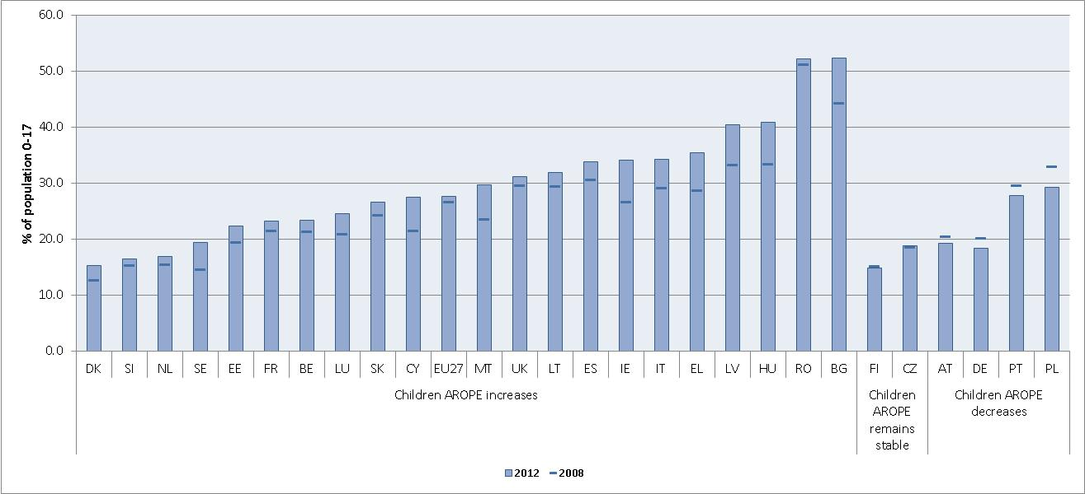
Source: Eurostat (EU-SILC), no 2012 data for BE, IE, AT, UK

In-work poverty risk for different household types, 2012
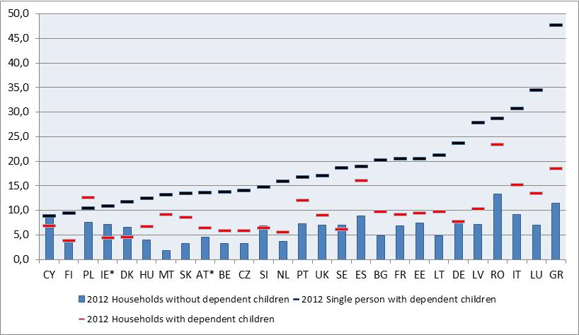

Part-time employment of population (15-64) due to looking after children or incapacitated adults responsibilities, 2011 – 2012
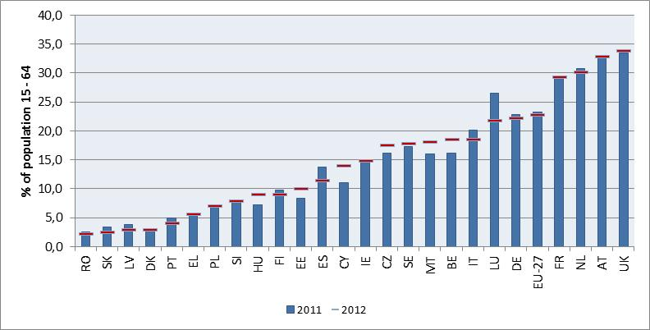
Source: Eurostat (EU-LFS), Note: no 2011 and 2012 data for BG, LT

Poverty reduction effect of family and child benefits for children aged 0-17
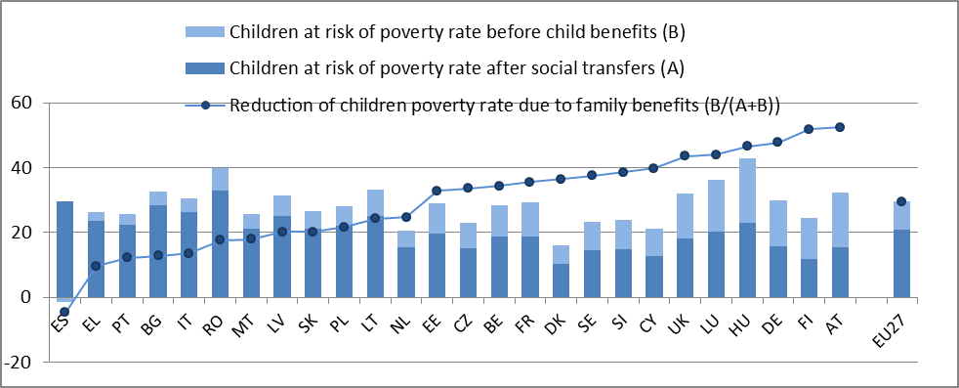
Source: Eurostat (EU-SILC UDB 2011), Calculations by DG EMPL

Percentage of children under 3 cared for in formal structures (and by weekly time spent in care) 2010-2011

This indicator corresponds to the sum of children who are: at risk of poverty, severely materially deprived or living in households with very low work intensity.
I.e. live in a household with an income below 60% of the national median income.
E.g. live in a household which cannot afford at least 4 items out of the following: 1) to face unexpected expenses, 2) one week's annual holiday away from home; 3) pay for arrears; 4) a meal with meat, chicken, or fish every second day; 5) keep the home adequately warm, 6) washing machine; 7) colour TV; 8) a telephone; 9) a personal car.
The work intensity of the household refers to the number of months that all working age household members have been working during the income reference year as a proportion of the total number of months that could theoretically be worked within the household.
http://www.eurofound.europa.eu/publications/htmlfiles/ef1264.htm, see p. 124
Available here
not including the Youth Employment Initiative allocation. (EUR 567 511248)
Regulation (EU) No 1303/2013 Regulation (EU) No 1301/2013 Regulation (EU) No 1304/2013 Regulation (EU) No 1305/2013 - Official Journal of the European Union L 347/2013 - OJ L 347, 20/12/2013 - http://new.eur-lex.europa.eu/legal-content/EN/TXT/?uri=OJ:L:2013:347:TOC

